|  |  |  |
| --- | --- | --- |
| BUSINESS UNIT  CUSTOMER CARE | | |
| TITLE  **Escrow (Call Center) Job Aid** | | PROCESS OWNER:  Garrett Browne |
| VERSION  18 | DOCUMENT ID  FSPID-1989020554-142 | APPROVAL DATE  [Approved (Compliance)] |
| APPROVED BY:  Matt Harbus | | LOB APPROVED DATE  2/2/2024 |
| CURRENT STATUS:  Published | | NEXT REVIEW  [Next Review/Due Date] |

TABLE OF CONTENTS

**Overview** 2

**Job Aid** 2

Commonly Used CITs Related to Escrow Requests 2

Escrow Analysis – Information 3

Insurance 23

Refund Checks 34

Payments 40

Mobile App Capabilities 45

Co-Issue Loans 47

**Appendix** 49

**OVERVIEW**

The purpose of the **Escrow (Call Center) Job Aid** is to provide guidance to the Customer Success Specialist (“Specialist“) with information on the Customer Inquiry Trackings (CITs) commonly used for Escrow requests, as well as when and how Escrow Analysis Statements are created, dispersed, and utilized.

Other clarifying topics include the handling of surpluses, shortages, removals, state guidelines, investor requirements, escalations, insurance, refund checks and co-issue loans. Detailed information on this subject matter is also addressed in the following separate job aids: Mortgage Insurance (PMI_MIP) - Call Center Job Aid and Escrow Tax (Call Center) Job Aid.

**JOB AID**

COMMONLY USED CITS RELATED TO ESCROW REQUESTS

# Commonly used CITs

* 1. The following is a list of the most commonly used CITs related to Escrow requests:
     1. 266 – Delinquent Tax Bill
     2. 267 – Tax Line Adjustment Maintenance
     3. 269 – Tax Refund Overpayment
     4. 566 – Escrow Analysis Requested (See below Escrow Analysis section)
     5. 567 – Shortage Spread Requested (See below Escrow Shortage section)
     6. 569 – Tax Research
     7. 585 – Payment Reallocation Request
     8. 675 – MI Denial/Disputes
     9. 683 – Escrow Refund Stop Payment Request - void and reissue (i.e., wrong name on check, deceased, Successor in Interest)
     10. 802 – MI CANC INQ Script Reject

ESCROW ANALYSIS – INFORMATION

# Escrow Analysis – Information

* 1. The Real Estate Settlement Procedures Act (RESPA) requires a Lender/Servicer to provide up to three different Escrow Statements to the customer during the life of the loan.

***Note:*** The statements to be issued depend on the circumstance.

* + 1. **Initial Escrow Analysis Statement (IEAS) –** An Initial Escrow Account Statement must be provided in conjunction with the origination of a loan, or within 45 days after the loan closes if an escrow account is to be established.
       1. The IEAS projects anticipated payments to be disbursed over the next twelve months and calculates the monthly escrow payment to equal 1/12th

of the annual requirement.

* + - 1. The balance required to establish the escrow account is calculated based on when the escrowed items are due to be disbursed from escrow.
         1. The lowest escrow balance must not exceed 1/6th (the two-month cushion) of the anticipated payments from escrow unless the mortgage contract or state law specifies a lower amount.
    1. **Annual Escrow Account Statement (EAS) –** Escrow Administration performs an annual analysis of the customer’s escrow account based on the state schedule listed in the Ordering a State Trial Report Job Aid or as needed.
       1. The EAS provides a *history of the escrow account since the last analysis* was performed detailing the escrow payments received and disbursements from escrow on behalf of the customer.
       2. The analysis *projects the anticipated disbursements to be paid over the next twelve months* and adjusts the base escrow payment to equal 1/12th of the annual requirement.
       3. The **required** escrow balance is compared to the **projected** escrow balance to determine if there are enough funds in escrow.
       4. A *shortage or surplus results* when the **required** escrow balance is less than (shortage) or greater than (surplus) the anticipated low point in reserves, **including the applicable cushion**.
          1. If a projected shortage results, it is automatically spread over 12 months and added to the base escrow payment to determine the new monthly escrow payment.

Per Consumer Financial Protection Bureau (CFPB) guidance, the EAS must not include the option to pay the shortage in full. However, the customer may elect to pay the shortage in full if they wish to do so; we merely cannot offer this option to them on the EAS per the CFPB.

If the calculated shortage increases the payment more than the customer can afford, they may request that the shortage be spread over a longer period (up to 48- months). You can request a 60-month escrow spread; however, you will need to reach out to your supervisor for approval prior to requesting.

* + - * 1. If the analysis results in a surplus, it is refunded to the customer in the form of a check and attached to the EAS.

A surplus less than $50 is retained in escrow account, unless otherwise dictated by state law.

If the loan is delinquent (as defined below) the surplus is retained in escrow until the loan is brought current and the customer requests that the surplus be released.

Escrow funds cannot be used to satisfy the delinquency.

* + - 1. A deficiency (defined as a negative escrow balance) may occur due to escrow advances made by Freedom Mortgage on behalf of the borrower.
         1. To recoup these advances from the borrower, an analysis must be performed to confirm the amount of the deficiency.
         2. If the deficiency is less than one month’s escrow payment, it may be collected in a lump sum.

Otherwise, the deficiency will be spread over 12 months or more (see above discussion regarding projected shortages).

# The following are included on the statement:

* + - * 1. Amount of the customer’s current total monthly payment.
        2. The portion of the monthly payment being deposited to the escrow account.
        3. The balance in the escrow account at the beginning of the previous period.
        4. The amount deposited into the escrow account monthly during the previous period.
        5. The amount paid out of the escrow account monthly during the previous period for taxes, insurance premiums, and other charges.
        6. The balance in the escrow account at the end of the previous period.
        7. The projected disbursements to be paid from escrow over the next 12 months.
        8. The calculated escrow payment projected to be paid into escrow over the next 12 months.
        9. An explanation of how the surplus is being handled by the servicer, if applicable.
        10. An explanation of how the shortage or deficiency is to be paid by the customer, if applicable.
        11. The reason(s) why the estimated low balance was not reached, indicated by noting differences between the recent account history and last year’s projection.
        12. RESPA allows the servicer to provide or deliver the annual escrow statement to the customer along with other statements or materials, including Form 1098, which is provided for federal income tax purposes.

Freedom Mortgage sends the Escrow Analysis Statement separately from any other mailings.

* + 1. **Short-year statements –** A short-year statement has the effect of ending the “escrow account computation year” for the escrow account.
       1. Freedom Mortgage must deliver the short-year statement to the customer within 60 days from the date that the loan pays off or is transferred to another servicer.
       2. The Short Year Statement provides a history of the escrow account from the last analysis through the date that escrow account ended.
          1. This includes disbursements that may take place from escrow after the loan has repaid.
          2. These disbursements may include a final Mortgage Insurance premium or a refund of the remaining balance on the loan after repayment.

# Delinquent Loans

* 1. If the loan is more than 30 days past due at the time Freedom Mortgage performs the escrow account analysis, Freedom Mortgage is exempt from the requirements of providing an annual escrow account statement to the customer.
     1. This exemption also applies where Freedom Mortgage has brought an action for foreclosure, or where the customer is in a bankruptcy case.
     2. If Freedom Mortgage does not issue an EAS and the loan is reinstated or becomes current, Freedom Mortgage must provide a history of the account since the last annual statement (which may be longer than 12 months at that point) within 90 days of the date the account became current.
     3. If Freedom Mortgage chooses not to provide the customer with a copy of an escrow analysis under this exemption, Freedom Mortgage still has an obligation to perform the escrow analysis on an annual basis.

# Escrow Analysis Tab in Salesforce

* 1. The Escrow Analysis tab within the Parent Case in Salesforce is used to quickly assess the change from one escrow analysis to another.

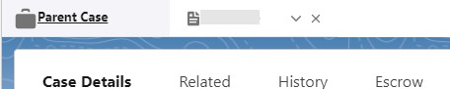

* 1. When the Escrow tab is clicked, the page will load with the two most recent EAS.

# Columns:

* + 1. PREVIOUS - Shows data for the escrow analysis that was prior to the “Most Recent”.
    2. MOST RECENT – Shows data for the most recent escrow analysis that is “Active”.
    3. DIFFERENCE – Shows the change in value from the “Most Recent” and “Previous” escrow analysis (if applicable).
       1. If only one escrow analysis exists on the loan, it will be displayed in the “Most Recent” column.
          1. When this happens, the number difference may not be true as Freedom Mortgage may not have record of the prior analysis.

Utilize the Electronic Document Management System (EDMS) to find any prior analysis if they exist.

* + - * 1. This can occur with bulk acquisition accounts or new loans where the prior analysis data is not available.
      1. Arrows on the right side of the difference are meant to be quick identifiers for changes in value.
         1. Up RED arrows indicate an increase and are typically negatively impacting the customer by increasing the payment.
         2. Down GREEN arrows indicate a decrease in change typically indicate a positive impact for the customer.

# Rows:

* + 1. Analysis Date, Analysis Statement Type, Effective Date, and End Date-
       1. This section shows the details of when the escrow analysis was completed, with what payment it is effective, and what day it stops being effective.
    2. Insurance and Tax-
       1. The information displayed will change based on what escrow line items are associated with the account being looked at.
          1. Each line item is grouped into like sections (i.e., insurance, taxes).
          2. The amounts are the MONTHLY amount and not the annual payment.
          3. Increases and decreases here will help explain the root cause why a shortage or overage exists.
    3. Monthly Escrow Shortage and Analysis Short Spread-
       1. If a shortage exists, the monthly shortage and the number of months the total shortage is spread over is detailed out.
          1. It will be easy to see if a shortage is increasing or decreasing.
    4. Monthly Escrow Payment, Monthly Principal and Interest Payment, Optional Products, and Total Monthly Payment-
       1. Here you will see the monthly breakdown of the payment and how it is being impacted.
          1. The Monthly Escrow Payment includes the monthly escrow shortage amount.

This will be their monthly escrow payment if they do not pay the shortage in advance.

* + - * 1. Optional Products are also listed in the comparison screen.
        2. The Total Monthly Payment will be the sum of the principal and interest (P&I), monthly escrow payment, monthly shortage payment, and any optional insurance monthly premium amounts.
    1. Payment Impact with Shortage-
       1. If a shortage exists in either month you will see a value here representing the total annual shortage.
          1. Total Payments with Shortage will be the same as the section above; this is the monthly payment amount without the shortage being paid.
          2. Total Payments without Shortage will be the monthly payment amount if the annual shortage was paid 100% prior to the effective date of the escrow analysis.

This is an estimate to quickly gauge in conversation with the customer on the monthly impact of the payment if they wish to pay the escrow shortage in full.

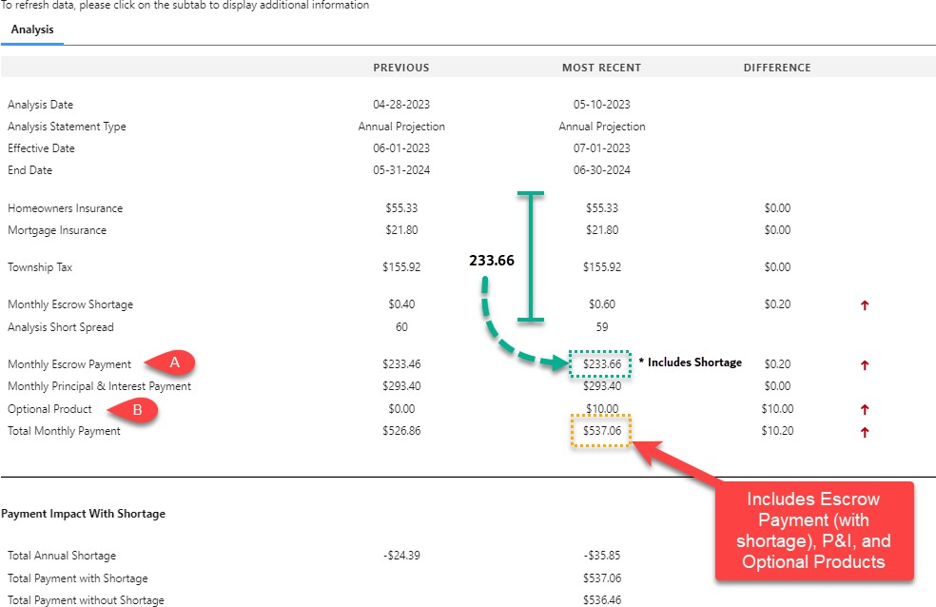

# Transfer of Servicing

* 1. If servicing of a loan is transferred and the new servicer changes either the monthly payment amount or the accounting method used by the previous Servicer the new Servicer must provide the customer with an IEAS within 45 days of the date of servicing transfer.

***Note:*** For recently acquired loans, the escrow analysis will run on the state schedule, but not within 60-days unless, there is an exception granted. If the new Servicer provides an IEAS upon the transfer of servicing, they must use the effective date of the transfer of servicing to establish the new escrow account computation year.

* + 1. When the new Servicer keeps and retains the monthly payments and accounting method used by the previous Servicer, the new servicer may continue to use the escrow account computation year established by the old servicer or may choose to establish a different computation year using a short-year statement.
    2. When a loan is transferred to a new Servicer, the previous Servicer must provide a short year statement to the customer within 60 days of the effective date of the transfer of servicing.

# EAS

* 1. The EAS informs the customer of:
     1. An escrow account surplus, shortage, deficiency, or if there is no change in the amount required in their escrow account.
     2. A check attached (surplus).
     3. No refund (surplus) due to the delinquent status of the customers’ loan.
  2. Escrow Analysis Statement types:
     1. Customers receive different messages on their statements, depending on the status of their account.
     2. Review the customer’s statement language by viewing the statement in LoanServ.
        1. To locate the customer’s statement, log into EDMS, click on “Default” and then Servicing Escrow Administration.

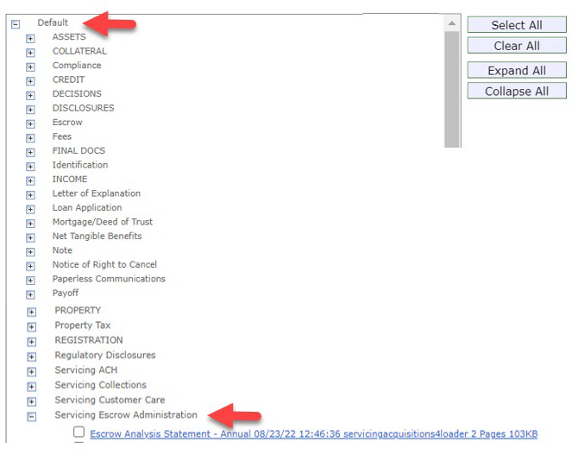

* + 1. Statement types include:
       1. Surplus that is greater than $50 with a refund check attached.
       2. Surplus that is less than $50.
       3. Short Year EAS – Loan transferred out.
       4. Shortage in the escrow account.
       5. Balanced Escrow account – No change in the amount required in the escrow account.
       6. Delinquent loan with less than $50 overage in escrow account.
       7. Delinquent loan with greater than $50 overage in escrow account.
  1. The Escrow Analysis Statement includes:
     1. The New Payment Amount and the effective date of the new payment.
     2. The statement begins with an explanation of why the customer is receiving the statement.

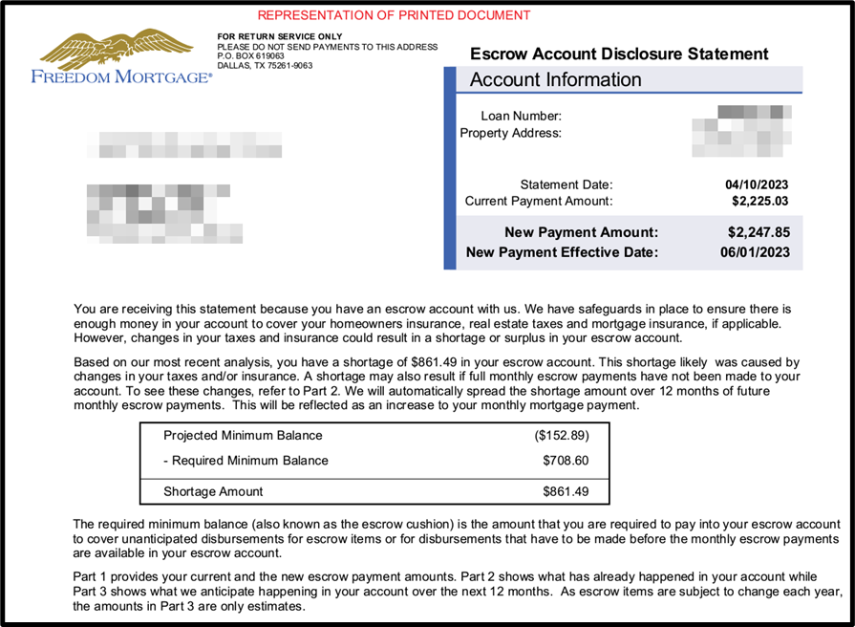

* + 1. An explanation of the “Required Minimum Balance”.
    2. A brief explanation of Parts 1, 2 and 3 on the EAS.

# Part 1 - Your Mortgage Payment

* + 1. Payment Information breaks down the P&I, Escrow payment, and if there is an escrow spread (shortage or overage).

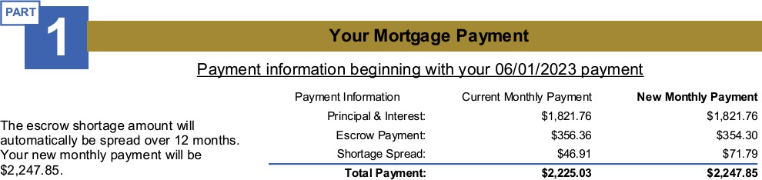

# Part 2 – Your Escrow Account History

* + 1. Explanation that the chart below shows what happened in their escrow account and what is expected to happen in the next 12 months.
    2. The chart shows the month/year of:
       1. The payments that were received.
       2. The payments made to their escrow account.
       3. What was estimated to be paid out.
       4. Description of the disbursements from the escrow account.
       5. The actual escrow balance.
       6. What the balance was estimated to be.

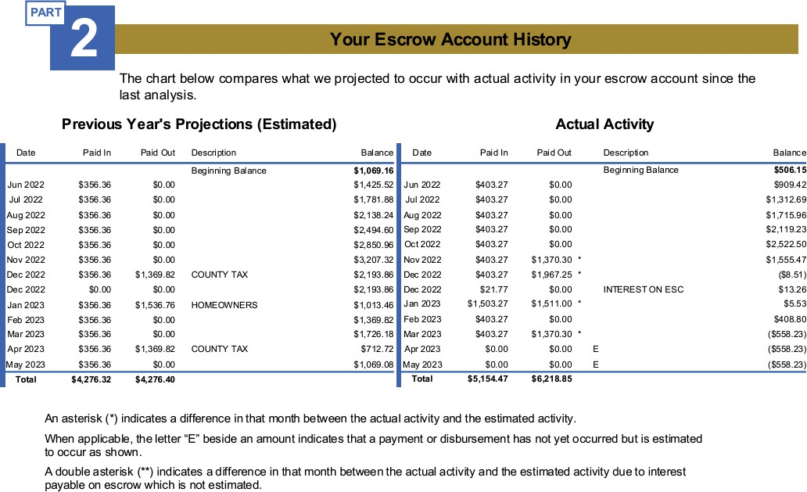

# Part 3 – Expected Escrow Payments over the next 12 Months

* + 1. This section provides a breakdown or expected disbursements from the escrow account.
    2. A summary of what is projected to occur in the escrow account in the next 12 months.
       1. This clearly displays what is expected to be paid into the escrow account along with the actual balance and the balance needed.

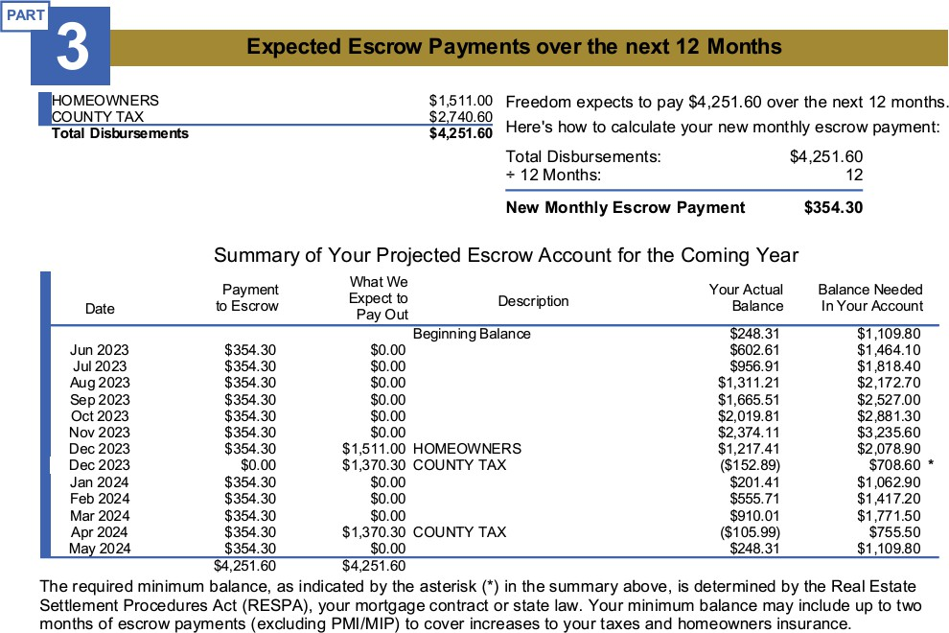

# Part 4 – What This Means to You

* + 1. Part 4 provides a brief summary of the statement and information regarding recurring payment set up via FreedomMortgage.com.

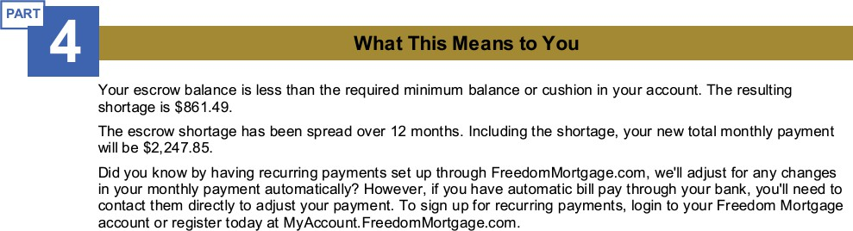

# Part 5 – How You Can Reach Us with Questions

* + 1. Part 5 provides contact information regarding customer questions.

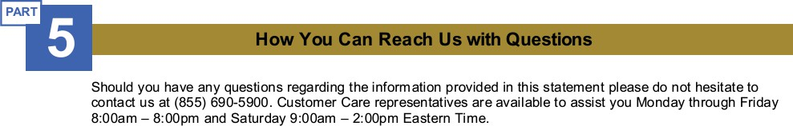

# Escrow Analysis - Common Customer Questions

* 1. Common customer Escrow Analysis questions:
     1. *I received my escrow analysis and there is a surplus, but my payment went up. Why?*
        1. Any surplus less than $50 will be utilized towards each month escrow payment due (unless state law dictates otherwise).
        2. We cannot retain more than a two-month cushion in your escrow account.
           1. However, the amount required each month increased due to the increase in your insurance policy and/or taxes due.
     2. *Customer received an escrow analysis, and it states there is a surplus but there is no check.*
        1. Make sure the letter is opened fully as the check would be the on the bottom/fourth fold.
        2. Escrow surpluses of $50 or less will not be refunded (subject to applicable law, e.g., Maryland).
           1. The surplus will be used to offset the escrow requirement for each month in the next year.
     3. *Customer requests their escrow account to be analyzed outside the annual cycle.*
        1. Customer believes there was a significant increase or decrease in the items (tax / insurance) in their escrow account that has been billed.
           1. Review for the loan closing anniversary date as this is when the next scheduled analysis will occur.

Let the customer know when their next scheduled EAS date is.

* + - * 1. Review to verify what the difference may be.

In cases of minimal impact to the customer, the Escrow Department will review each request for impact and will determine whether to complete an unscheduled analysis or wait for the annual cycle.

* + - * 1. If the request needs to be submitted to run an unscheduled analysis, open

**CIT 566** to request the analysis.

* + 1. *Does the customer have an option to have a greater than a 12-month spread?*
       1. Yes, if the shortage will cause the customer to experience a hardship you may request a 24, 36 or 48 months spread.
          1. Request for greater than 48 months must be reviewed and receive approval from your supervisor.
       2. The shortage will be equally divided by the number of months the customer has elected to spread the shortage and included as part of their escrow payment for repayment.
    2. *How much of a cushion do states require?*
       1. All states require a 2-month cushion with the exception of the below:
          1. Montana (MT) = 1 month
          2. Nevada (NV) = 0
          3. North Dakota (ND) = 0

***Note:*** Vermont (VT) is no longer included on the exception list. As of March 21, 2017, the maximum cushion was increased from 1/12 (one month) of the total annual disbursements to 1/6 (two months).

* + 1. *Why is PMI/MIP not included in the two-month cushion?*
       1. RESPA does not require a cushion for PMI/MIP.

# Escrow Analysis – State Schedule

* 1. See the Ordering a State Trial Report Job Aid for further information.

# Escrow Removal Request:

* 1. The customer may request to have their entire escrow account or escrow line to be removed.
     1. All requests must be submitted in writing.
     2. Before advising the customer to submit their request in writing for the Escrow Department to review, use these guidelines to determine if the loan meets the removal requirements below.
        1. Eligible accounts:
           1. Conventional loans not considered a high-priced mortgage loan (HPML)
           2. U.S. Department of Veterans Affairs (VA) loans
        2. Ineligible accounts:
           1. Federal Housing Administration (FHA) loans
           2. Loans with Completed Modifications (by Freedom Mortgage or any previous Servicer)
           3. United States Department of Agriculture (USDA) loans
        3. Escrow elements that may be removed:
           1. Hazard insurance
           2. Real Estate taxes
        4. Escrow elements that cannot be removed:
           1. Mortgage insurance unless the account is qualified for removal under the PMI cancellation process.
           2. Flood insurance if the property is located on a Special Flood Hazard Area (SFHA).

# Qualifications for Removal

* 1. A customer written request to initiate the escrow removal review is required.
     1. An account must be at least 24 months seasoned from either the origination date or following completion of a repayment plan.
     2. The Loan-to-Value (LTV) must meet investor requirements based on the original appraised value.
     3. The payment history must not reflect any delinquency in the 12 months immediately preceding the request and no 60 plus day delinquency in the 24 months immediately preceding the request.
     4. A customer who has received a loan modification is not eligible.
     5. A customer who has failed to make timely payments for taxes or insurance (T&I) under a prior escrow waiver are not eligible.

# State-Specific Guidelines

* 1. Guidelines-
     1. Illinois (IL)– can be terminated, upon customer request, when the loan is reduced to 65% of its original loan amount.
     2. Minnesota (MN)– can be terminated upon customer request, after the fifth (5th) anniversary of the origination date, if certain conditions are met.
  2. If the customer meets the parameters listed above, advise the customer to submit their escrow removal request in writing by fax to 866-505-0948 and provide as many details as possible to ensure their request is completed accurately.
     1. The Customer Success Specialist should say: “Mr./Mrs. upon my initial review of your account you may be eligible to remove your escrow account. Please send in a written request to be reviewed, it can be sent by fax to 866-505- 0948.
     2. The customer must specify one of the following in the written request:
        1. Request Escrow to be removed completely or request one of the Escrow lines to be removed.
     3. Never advise the customer they meet the criteria.
        1. If the customer meets the requirements above, the request can be submitted but the final decision will be made by the Escrow Department.
        2. The Escrow Department will review the account to make sure the customer meets the removal requirements.

# Escrow Requirements on HPML Loans:

* 1. The final Truth in Lending Act (TILA) HPML Escrow Rule has these main elements:
     1. Customer must establish and maintain an escrow account for at least five years from the closing date regardless of LTV ratio.
     2. Customers must maintain the escrow account until one of the following occurs:
        1. Underlying debt obligation is terminated.
        2. The customer requests that the escrow account be canceled after the five- year period.
     3. If canceling the escrow account at the customer’s request:
        1. The loan’s unpaid principal balance (UPB) must be less than 80 percent of the original value of the property (80% LTV ratio).
        2. Customer must not be delinquent or in default on the underlying obligation.
  2. Requirements/Qualifications-
     1. Customer’s written request to initiate the escrow waiver review.
     2. Loan must be at least 24 months seasoned from either the origination date or following completion of a repayment plan.
     3. The LTV must be less than 80% (based on the original appraised value).
     4. Payment history must not reflect more than one 30-day late in the last 12 months and not more than one 60+-day delinquency in the last 24 months.
     5. Customers who have received a loan modification are not eligible.
     6. Customers who have failed to make timely payments for taxes or insurance under a prior escrow waiver are not eligible.
  3. Properties that are insured by a Condo Master policy are required to maintain HO6 coverage (which can be escrowed).
     1. Customers do not have to escrow for insurance premiums for properties located in: Condominiums, Planned Unit Developments (PUDs), and other common interest communities where the homeowners must participate in governing associations that are required to purchase master insurance policies.
  4. FHA and USDA Escrow Requirements:
     1. FHA and USDA do not permit cancellation of required escrow accounts at any time.
        1. In other words, lenders may not cancel escrow accounts on FHA and USDA loans whether they are HPMLs or not.
  5. Non HPML Escrow Requirements:
     1. If the loan is not HPML, the requirement for escrows is based on Agency/Investor guidelines.
  6. Identifying HPML loans in LoanServ:
     1. The alert section in the Servicing system of record, LoanServ, will show a flag, “Higher-Priced Escrow Required” which identifies the loan as being an HPML.

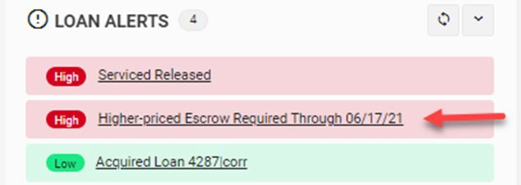

* + 1. Once you click on the alert you will see the screen below, which also identifies HPML.
       1. Disregard 00/00/00 and refer to the closing date on the system to calculate 5 years rule.

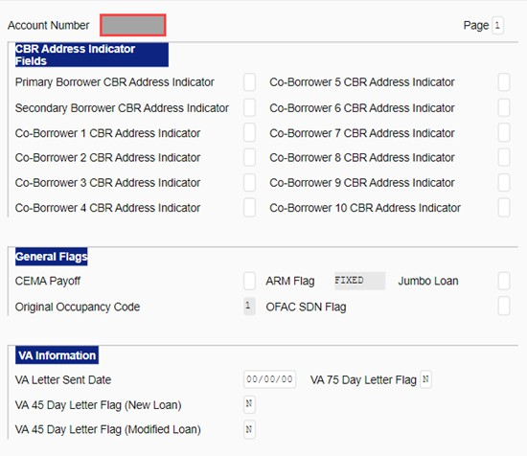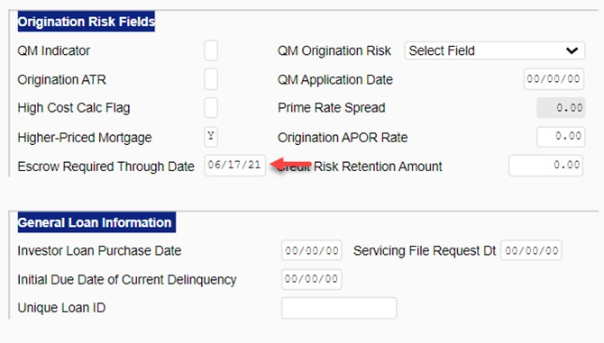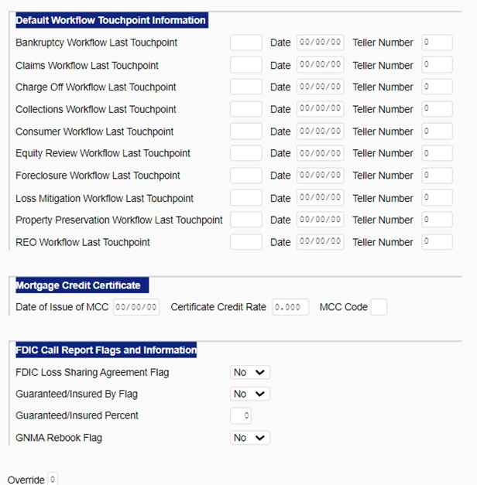

# Full or Partial Payment of Escrow Shortage:

* 1. When a customer is making a full or partial payment of their escrow shortage, CIT 585 (Payment Reallocation Request) should be opened.
     1. Prior to opening CIT 585 for a transaction effective in the prior year, validate that the adjustment is absolutely necessary as this will have tax statement implications.
     2. Do not open CIT 585 to complete a secondary escrow analysis.
  2. A shortage is the amount by which a current escrow account balance is less than the required target balance. If the actual amounts due for escrowed items are more than what was projected on their last or initial escrow analysis statement, the account may have a shortage when the bills are paid.
     1. The borrower may choose – but is not required – to pay the full amount of the shortage by using the remittance coupon that we send to them.
     2. They may simply accept the new monthly payment amount going forward.
     3. Shortage payments must be mailed to the address specified on the coupon so that the payment is posted correctly.
     4. Additionally, they may (but do not suggest this) pay less than the full amount of the shortage, but more than the minimum amount required as part of their monthly payment. If the borrower wants to do this, please inform them that:
     5. All properly submitted shortage payments will be applied towards the shortage, and the necessary calculation (if appropriate) to reduce their monthly payment will occur via the system.

**Note:** Any recalculation will not reduce the payment to what it was prior to the most recent escrow analysis.

# Escrow Shortage-Common Customer Questions

* 1. Common Customer Escrow Shortage questions:
     1. *Customer received their escrow account analysis statement, and it reflects a projected shortage.*
        1. Determine which type of escrow analysis was performed: First, Annual, or Short Year End.
           1. First - This is the first annual analysis (usually closed in last year).

Yes - Pull up the IEAS and Closing Disclosure in EDMS.

* + - 1. Compare what was collected.
         1. Annual - Is this the anniversary of the last analysis?
         2. Short Year End - Did this loan transfer to another servicer or pay off?
    1. *If the customer pays the escrow shortage in full will a payment go back to what it was prior to this analysis?*
       1. It depends on what caused the shortage.
          1. If there was a shortage due to not enough months collected at closing, the payment may not increase.

This is unlikely but possible IF the shortage is paid in full and IF each escrowed item remained the same.

* + - * 1. If there was an increase of amount due on escrowed item (i.e., taxes, insurance) over what was previously projected (at closing or the last EAS) the escrow portion of their monthly payment would still increase, to cover these upcoming escrow disbursements.
    1. *How will the escrow shortage be paid back?*
       1. The option to pay in one lump sum or to spread the shortage over 12 months is up to the customer.
          1. If we do not receive the shortage payment, we will automatically spread the shortage over 12 months.
       2. If the customer requests a longer spread (up to 48 months), open CIT 567 (C&R–Shortage Spread Request) to request this exception.
       3. Any request greater than 48 months must be reviewed and submitted by a supervisor or above.
    2. *Does the customer receive any notification when their shortage is paid via mail?*
       1. Yes, the shortage payment will reflect on the following month billing statement.
       2. Do not inform the customer that a new escrow analysis will be run.

# Escalations to the Escrow Department

* + 1. The process when dealing with an issue that needs to be escalated to the Escrow Department (Customer looking for expedited requests or responses.).

***Note:*** Emails should only be sent by a supervisor.

* + - 1. When emailing the Escrow Department on an escalated issue your email should be formatted as follows:
         1. To: Escrow Administration
         2. Subject: ESC Request / Loan #
         3. Body of the email:

Loan#

Customer Name:

Request:

Reason for Escalation

* + - 1. When emailing the Escrow Department on an emergency escrow issue (i.e., regulatory complaints, upper management requests, substantial financial or reputational risk to Freedom Mortgage), your email should be formatted as follows:
         1. To: Escrow Administration
         2. CC: Call Center Manager and AVP
         3. Subject: *Urgent / Need a Response /a.s.a.p. / Escalation, Escalated issue

/ Management Request /CFPB / BBB (Complaint) LOAN#

* + - * 1. Body of the email:

Loan#

Customer Name:

Request:

Reason for Escalation

INSURANCE

# Homeowners Insurance

* 1. Adequate insurance coverage is required to be maintained on the property throughout the life of the loan.
     1. The homeowner is required to provide an active policy(s) for the property at the time of the loan closing.
        1. If a premium is due to be paid within 60 days after closing, the premium is to be paid on the Closing Disclosure to ensure that there is not a lapse in coverage due to non-payment.
     2. Freedom Mortgage must be named in the Mortgagee Clause on the policy.
        1. This ensures that Freedom Mortgage receives policy notifications (i.e., Declaration page, cancelation, reinstatement, policy renewal), as well as being listed as the Loss Payee in the event of a loss to the property and a claim is filed.
     3. Required insurance coverage is tracked for all loans that Freedom Mortgage services, whether the insurance premium is included in escrow or not.

1. **Insurance Policy types** that are required at origination and throughout the life of the loan varies depending on the property.

# Hazard Insurance

* + 1. Fire, some catastrophic conditions, theft and/or losses as defined in the policy.
    2. The required coverage is the lesser of:
    3. 100% of the insurable value of the improvements, as established by the property insurer, which should be equal to the replacement cost of the improvements as determined by the appraiser **OR** the unpaid principal balance (UPB) of the mortgage (loan amount), as long as it equals the minimum amount –usually 80%

of the insurable value of the improvements – is required to compensate for damage or loss on a replacement cost basis.

* + 1. Dwelling coverage must be at least equal to the principal balance or 80% of the replacement cost.

# Flood Insurance

* + 1. Required by the Federal Emergency Management Agency (FEMA) on properties that are located in a Special Flood Hazard Area (SFHA).
    2. Flood zones A and V are required to be escrowed if any other item is escrowed on the loan.
    3. The minimum amount of flood insurance required is the lower of:
       1. 100% of the replacement cost of the dwelling; **OR**
       2. The maximum insurance available under the appropriate National Flood Insurance Program (NFIP), which is currently $250,000 per dwelling; **OR**
    4. The UPB of the mortgage loan.

# Wind Insurance

* + 1. Required for properties located in high wind states.
    2. Required as a separate policy if wind coverage is specifically excluded on the Hazard Policy.
    3. Coverage requires are the same as Hazard Insurance.

# HO-6 / Walls-In Insurance

* + 1. Additional insurance coverage required for permanent fixtures and furnishings for the interior of the unit.
    2. HO-6 insurance may not cover personal belongings.
    3. It does cover items like kitchen cabinets, flooring, toilets, sinks and counter tops.
    4. The required coverage must be an amount, as determined by the insurer, which is sufficient to repair the condo unit to its condition prior to a loss claim event.
    5. The policy must clearly state that it is a walls-in policy.

# Condo / PUD / Co-Operatives (Co-Ops) Master Policies

* + 1. Coverage that ensures the value of the entire structure and is paid by the Condo or Homeowners Association.
    2. The required coverage for a condominium should cover 100% of the insurable replacement cost of the project improvements, including individual units.
       1. A policy that contains one of the following endorsements will assure full insurable value replacement cost coverage:
          1. A Guaranteed Replacement Cost Endorsement-under which the insurer agrees to replace the insurable property regardless of the cost and if the policy includes a coinsurance clause, an Agreed Amount Endorsement – which waive the requirement for coinsurance **OR**
          2. A Replacement Cost Endorsement –under which the insurer agrees to pay up to 100% of the property’s insurable replacement cost, but no more and if the policy includes a coinsurance clause, an Agreed Amount Endorsement-which waive the requirement of coinsurance.
          3. Extended Replacement Cost Coverage- under which the insurer agrees to pay more than the property’s insurable replacement cost .

# Escrowed Loan

* 1. Freedom Mortgage will pay the insurance premium due at the time of policy renewal from the escrow account.
     1. If a policy renewal is not received, the Insurance Department will attempt to contact the last known carrier in order to obtain renewal information.
     2. We will not pay the last known carrier by default as the customer may choose to obtain coverage with another carrier.

# Lender-Placed Insurance (a/k/a Force-Placed Insurance)

* 1. Lender-Placed Insurance (LPI) is an insurance policy that is purchased by the Servicer to protect the interest of Freedom Mortgage as the lienholder and the Investor.
     1. The LPI policy covers only the improvements (i.e., structure, permanently affixed cabinets).
        1. Personal belongings and liability are not included in the policy coverage.
     2. The LPI premium is the responsibility of the customer and payment is advanced from the customer’s escrow account.
     3. The account will be analyzed to adjust the monthly payment to recapture the premium that was paid.

# Scope of Consumer Financial Protection Bureau (CFPB) Force-Placed Insurance Rule

* + 1. The CFPB issued rules that took effect January 10, 2014, amended certain RESPA rules; one amended rule impacted Force-Placed/LPI.

***Note:*** Flood Insurance requirements are governed under the Flood Disaster Protection Act (FDPA) not under CFPB.

* + 1. Applies to all federally related mortgage loans.
    2. Servicers acting as debt collectors under the Federal Debt Collection Protection Act (FDCPA) must still send the LPI letter statements even when the customer has sent a written cease communication request.
    3. There is a 45 Day Notice period required before LPI can be purchased.
       1. Required timing of Lender-Placed Insurance letters:
          1. 1st LPI letter – Must be sent at least 45 days prior to paying for coverage and includes Binder coverage to protect the property in the event of a loss if preferred coverage is not present.
          2. 2nd LPI letter – Must be sent at least 15 days prior to paying for coverage.
       2. All LPI notices must be sent by first-class mail.
       3. If no response is received to either notice, on day 46 or later, the LPI policy is placed and the premium is paid from escrow.
       4. The effective date of the LPI policy is the expiration date of the last known policy, or the responsibility date of the servicer in the event of a new loan (closing date) or newly acquired loan (date of transfer).
       5. If the customer does not obtain their own preferred insurance policy and the LPI policy expires, a new LPI cycle will begin following the same 45- day notification schedule.
    4. Adequate evidence of insurance on the property must be received in order to have the LPI policy cancelled.
       1. If there is no lapse in the coverage period, the policy will ‘flat cancel’.
          1. A full refund of the premium that was paid will be refunded, if applicable.
       2. If there is a lapse in coverage terms, a partial cancelation of the policy will take place.
          1. The premium due for the dates of non-coverage will be paid from escrow, if applicable.
          2. A partial refund of the premium previously paid will be calculated to cover only the time period for the lapse in coverage, if applicable.
       3. Any refund due to the customer must be credited within 15 days of policy cancelation.
    5. There is required language and specific bolded phrases and sentences in each LPI notice.

# Loss Draft

* 1. Loss Draft is a term used when there has been a natural disaster (e.g., fire, hurricane, and flooding) and the homeowner opens a claim with the homeowner’s insurance company to repair the damages.
  2. It is the customer’s responsibility to ensure that any damage to the property is repaired so that the property improvements maintain the value of the loan.
     1. A property inspection may be ordered to ensure that our interest is protected, and the homeowner can return their property to the same (or better) condition prior to the damage.
     2. After the carrier’s insurance adjuster determines the loss and the funds required to repair the property, a loss draft check will be issued to both the customer and to Freedom Mortgage for both to endorse.
        1. This happens because Freedom Mortgage has a financial interest in the property and the insurance company honors and protects that.
        2. If the loss is equal to or under $10K the check will be signed and returned to the customer.
        3. Loss Draft funds are placed into a “restricted” escrow account to be used only for the repairs of the home.
     3. The Loss Draft Department/Proctor manages the tracking of repairs and release of funds to the customer and/or the home repair contractors.
        1. Obtains receipts and release forms from the customer and contractors.
        2. Places required inspections (at the cost of Freedom Mortgage).
        3. Funds are disbursed as repairs are completed in accordance with Investor guidelines, the loss adjustment documentation and/or signed accepted contracts of repair.
        4. The requirements vary depending on the Investor, the amount of the claim, the type of loss that occurred and the delinquency status of the loan.

***Note:*** In cases of a natural disaster, when a large community of people are impacted, processes and procedures may change per investor guidelines. Specific information, guidelines and scripts will be distributed for your use in a catastrophic event.

# How to Handle Loss Draft calls

* + 1. Greet and authenticate the customer.
    2. Once you determine that the customer is calling about their Loss Draft check: handle the call as indicated in Freedom Servicing Phone Numbers and Addresses (Call Center).

# Quick Tip

* + 1. Customers need to speak to our Insurance Department in order to get the correct information on where to send their loss draft checks.
    2. There are different endorsement rules based on loan status and check amount, and that they need to speak with the Insurance Department to get the details on how their claim will be handled.
    3. Transfer these customers to our Insurance Department as indicated in Freedom Servicing Phone Numbers and Addresses (Call Center).

# Mortgage Insurance

* 1. Lenders require a 20% down payment for a home purchase or 20% equity in the home for a refinance.
     1. If the Loan-To-Value (LTV) is less than 20% of the appraised value or sale price, Mortgage Insurance (MI) is required in order for the customer to obtain the loan.
  2. The purpose of MI is to reduce the risk and protect the lender in the event that the customer defaults on the loan.
     1. MI ensures that the servicer/investor will be paid in full, including most expenses, in the event of a customer default.
     2. MI allows the customer to make a smaller down payment.
     3. Customers are required to maintain MI until they have accumulated additional equity in their home.
  3. In most cases, MI premiums are paid from escrow.
     1. Some MI premiums are paid by the Lender (Lender Paid Mortgage Insurance – LPMI).

Depending on the loan program and type of insurance the customer qualifies for, MI is paid in monthly installments, a lump sum when the loan closes, or a combination of both.

# Private Mortgage Insurance (PMI)

* 1. PMI is required on conventional loans with an LTV greater than 80%.
     1. There are several ways PMI premiums can be paid:
        1. A single premium charged upfront (UFMIP) or financed in the loan.
        2. A monthly premium included as part of the customer’s escrow portion of their monthly mortgage payment.
        3. A split-premium, a portion paid up front with a smaller monthly premium.
        4. Annual premium paid once a year.
     2. Federal law allows the customer the right to request the Lender to cancel PMI on their loan when the principal balance of the loan is scheduled to amortize below 80% of the original value of the home.
        1. This date is given to the customer in writing on a PMI disclosure form when the loan closes.
     3. Some states have other statutory requirements pertaining to PMI removal.
        1. Minnesota (MN) for example, permits a customer to request PMI removal based on current value at 80%, based on a current fair market appraisal valuation (at their cost).
     4. Automatic termination is required on the date that the loan is scheduled to reach 78% of the original appraised value of the home or the first day of the month after the mid-point of the mortgage amortization.
        1. The loan must be current and cannot be terminated until all payments are up to date.
        2. The PMI must be terminated even if the property value has declined.
     5. The customer may request to cancel PMI prior to the scheduled termination date if the customer made additional curtailments to the principal balance of the mortgage or if they believe that the value of their home has increased.
        1. The customer must submit a written request.
        2. The customer must have a good payment history, which is defined as not having been 60 days delinquent in the 12 months period beginning 24

months before the cancellation date or 30 days delinquent within the last 12 months.

* + - 1. The customer must certify that there are no junior liens.

The Lender may require evidence to prove the value of the property hasn’t declined below the original value.

# FHA Mortgage Insurance Premium (MIP)

* 1. The Federal Housing Authority (FHA) insures the loan through a government program and can only be offered through an approved FHA Lender such as Freedom Mortgage.
     1. Some benefits of an FHA loan are a 3.5% down payment (96.5% LTV), the loan can be refinanced without an appraisal, and FHA mortgage rates are usually lower than conventional loan rates.
  2. All FHA loans are required to maintain the MIP for the term.
     1. The premium is paid two ways:
        1. An upfront premium (UFMIP) which can be paid in cash or may be financed into the loan amount.
        2. A monthly premium, which is included in the escrow portion of the monthly mortgage payment.
     2. Since the UFMIP is to be paid in full at closing, it cannot be refunded if paid for in cash and it cannot be removed if financed into the total loan amount.
     3. The table below shows the duration of annual MIP by amortization term and LTV ratio at origination.

|  |  |  |
| --- | --- | --- |
| **Loan Term** | **Orig LTV (%)** | **Premium Term in Years** |
| ≤ 15 years | ≤ 78 | 11 years |
| ≤ 15 years | > 78 – 90.00 | 11 years |
| ≤ 15 years | > 90.00 | Loan term |
| > 15 years | ≤ 78 | 11 years |
| > 15 years | > 78 – 90.00 | 11 years |
| > 15 years | > 90.00 | Loan term |

* + - 1. Loans originated prior to June 2013, the MIP will be terminated once the UPB reaches 78% LTV either by amortization or customer made curtailments and a new appraisal.
    1. Lenders are required to submit mortgage insurance payments to the U.S. Department of Housing and Urban Development (HUD).

# USDA

* 1. USDA loans do not require a down payment (up to 100% LTV or greater) and the MI premium is usually a lower cost than FHA MIP.
     1. USDA loan-eligible areas tend to be in more rural areas and have an income ceiling for a customer.
     2. You may hear USDA loans referred to as “Rural Housing Loans” or “Section 502 loans”.
  2. The USDA Guarantee Fee is made up of two parts: the Funding (Guarantee) Fee and an Annual Fee.
     1. Additional information and rates can be found in the [USDA Handbook: HB-1-](https://www.rd.usda.gov/resources/directives/handbooks) [3555 SFH Guaranteed Loan Program Technical Handbook](https://www.rd.usda.gov/resources/directives/handbooks)

# Open the HB-1-3555 SFH Guaranteed Loan Program Technical Handbook.

* + - 1. Click on **Appendix 1.**
      2. Navigate to the section on **Application for and issuance of the loan guarantee**.
    1. The Funding Fee is a standard percentage of the loan amount financed on top of the total loan amount.
       1. This is not out of pocket money but a premium that is added to the Base Loan Amount.
    2. The Annual Fee is a percentage of the outstanding loan amount and is included in the monthly escrow payment.
       1. USDA's Annual Fee that is collected each month in the customer’s escrow portion of their mortgage payment will never terminate.
       2. It will remain a part of the monthly payment until the USDA mortgage is paid off.
          1. However, the annual fee will lower each year since it is recalculated annually and is based on the unpaid principal balance.

# 1098 - Customer issues on VA loans

* 1. *A Customer calls in on their VA loan and states that they is getting charged MIP per their Form 1098, Mortgage Interest Statement.*
     1. What does this mean for you?
        1. Customers may call in with questions around their 1098, about the Mortgage Insurance Premiums (MIP) paid.
        2. You’ll need to identify potentially impacted loans and be aware of the issue.
  2. *How do I identify if a loan was impacted or had an error?*
     1. Check to see if it was a correspondent loan.
        1. The Green “Acquired Loan” loan alert will have “CORR” listed in it.



* + 1. If so, check the 1098 that was sent in EDMS.
       1. 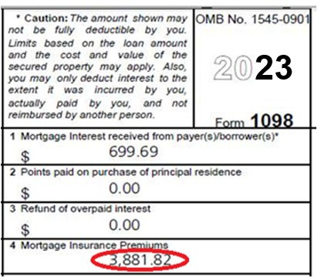It will show you how much was reported for MIP.
    2. Go to Dis Sum and see how many MIP payments were made in 2015.
       1. In this case the customer only paid 1 payment for $149.82.

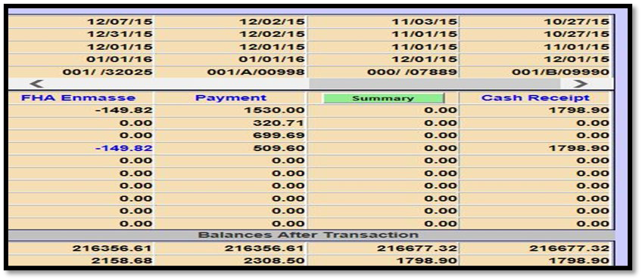

* + 1. With that payment in mind, take this and add it with the MIP paid at closing on the Closing Disclosure.
       1. It is usually line 902.

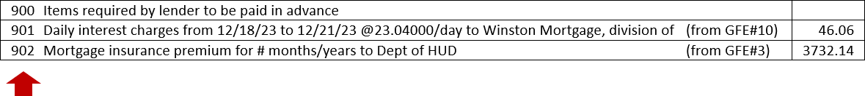

* + 1. In this example, you can see that there was $3732 paid by MI at closing. $149 +

$3732 = $3881.

* + - 1. If you remember, this was the amount reported on the 1098 from Freedom Mortgage we saw in EDMS.

# What do I tell the customer?

* + - 1. As always, remain empathetic to the customer.
      2. Let the customer know that Freedom Mortgage is aware of this error and we’re working on sending a corrected 1098’s as soon as possible.
  1. *Customer receives a letter from an outside third party stating to contact Freedom Mortgage and open a case to have your MIP reduced.*
     1. Things to know:
        1. For a customer to reduce the MIP amount they would have to refinance the loan.
        2. This kind of third party is trying to get the customer to refinance.
     2. Steps to handle a call like this.
        1. If the customer calls in regard to reducing their MIP amount, explain for this to happen they would need to refinance the loan.
        2. If the customer is interested in refinancing the loan, transfer the call over to the Refinance Department.

REFUND CHECKS

# Stale Dated Refund Check

* 1. When a refund or escrow check is sent, the customer has 180 days to cash the check.
     1. If they do not cash the check in that timeframe, the check becomes voided and the customer’s funds are placed back into their escrow account.
     2. The customer will receive a letter explaining what has occurred.

# Important information about escrow refunds:

* + 1. These checks are issued when an escrow surplus is discovered as a result of an escrow analysis.
    2. Check the customer’s account number.
       1. A re-issued check request must be opened on the account for which the check had been previously issued.
    3. There is a 10 business-day waiting period before surplus check from escrow analysis can be re-issued.
    4. Inform the customer it can take up-to 30 days from the date of the request for them to receive their escrow surplus check.
    5. Original refund check needs to have aged 30 calendar days from issue date before check can be requested to be re-issued.
    6. Check is issued under name/s on the loan, any name or address changes need to happen prior to requesting check replacements.

# Steps:

* + 1. Identify the check was put back into escrow account by reviewing the Dis/His screen in LoanServ and finding the M01 Transaction code.

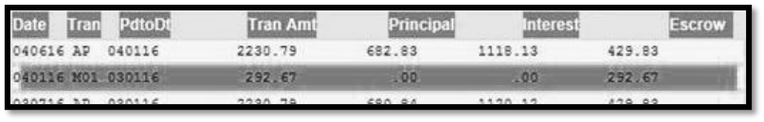

* + - 1. Also review the Dis/Notes screen to see if it notes the check was voided (see examples below).
    1. Identify if the Request is on an active loan or a paid off loan.

# Active loan:

* + - * 1. Refund check #xxxxx, iao $xx,xxx.xx, dated xx/xx/xx was voided due to the status of the check – outstanding over 180 days from issuance.
        2. Since this check is no longer negotiable, the refund amount has been returned to the escrow account.

# Paid off Loan:

* + - * 1. Refund check #xxxxx, iao $xx,xxx.xx, dated xx/xx/xx was voided due to the status of the check – outstanding over 180 days from issuance.
        2. Since this check is no longer negotiable and the loan has been refinanced with Freedom Mortgage, the refund has been returned to the escrow account associated with the refinanced loan account.

# Steps to proceed with Check Issuance:

* + - 1. **Active Loans**
         1. If the customer would like the funds re-sent and the loan is still active.

Open CIT 683 (Escrow Refund Stop Payment Request).

Include that the customer is asking for the check to be re-sent.

The original check number.

The amount of the original check and the date issued.

You can find this information on the Dis/Check screen.

Advise the customer a check will be issued in the next 10 business days.

# Paid off loans

* + - * 1. If the customer would like the funds re-sent and the loan is not active:

Review Dis/Notes screen to confirm if refund check was stale and voided.

If voided:

A message will have been placed on the loan.

“Paid off Loan: Refund check #xxxxx, iao $xx,xxx.xx, dated xx/xx/xx was voided due to the status of the check – outstanding over 180 days from issuance.”

Open CIT 683 (Escrow Refund Stop Payment Request).

If not voided:

No “Voided” note placed on the loan.

Open CIT 683 (Escrow Refund Stop Payment Request) and include that the customer is asking for the check to be re-sent and include the original Check #, amount of the check, and date issued.

This information can be found on the Dis/Check screen.

Verify mailing address in LoanServ.

If the returned check is imaged in EDMS, advise the customer a check will be issued in the next 72 hours.

You must enter the text of CIT that the returned check is imaged in EDMS in order for the new check to be issued in 72 hours.

If there is no returned check in EDMS and older than 30 days open CIT 683 (Escrow Refund Stop Payment Request).

Treasury will reissue in 10 business days.

***Note:*** Refunds can only go to customer in check form, **not** ACH.

# Escrow Refund Checks

* 1. **What is the Process? Why does this happen?**
     1. Escrow refund checks can be issued as the result of an overage from an escrow analysis.
     2. Escrow refund checks can be issued as the result of an overage from a paid off account.
     3. Escrow refund checks that have been issued can be used to repay an escrow advance/escrow note.

# The Process:

* + 1. Once the analysis is complete and it is determined there is an overage or once an account is paid off an escrow refund check is issued and sent to the customer.
       1. The check is valid for 180 days.
    2. If the check is not cashed after 60 days from issue, a letter is sent to the customer encouraging the customer to cash the check before it expires.
       1. If the customer calls in, we need to determine:
          1. Was the check received?

If “yes”, determine whether the funds received by the customer need to be repaid per the Escrow Note.

The Escrow Note can be retrieved in EDMS.

Open the Default folder.

Select the collateral folder.

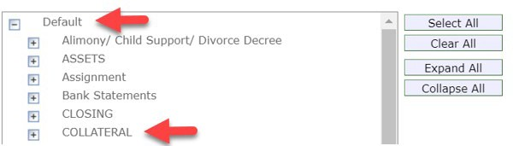

Pull up the Note.

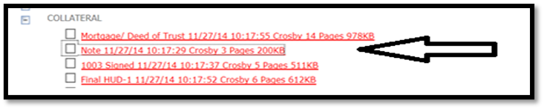

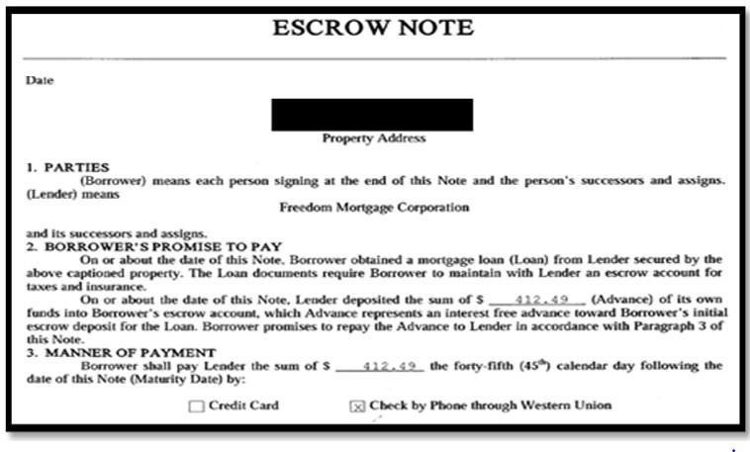

The Escrow Note will state the amount that was agreed to be withdrawn from customer’s account.

Date of Automatic Withdrawal – 45 days from date of note.

Could be a few before or after, inform customer that funds will be taken out even if not on exact date.

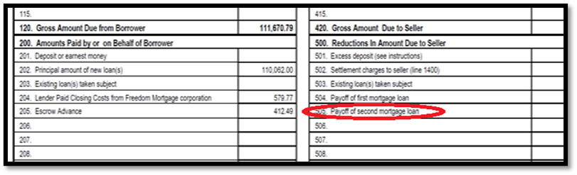The Closing Disclosure will also show escrow advance.

If “yes” and no escrow note exists, encourage them to cash the check.

If “no”, we need to reissue a new check.

***Note:*** Verify correct customer Mailing Address.

# Order Replacement Escrow Refund Check

* + 1. Open CIT 683 (Escrow Refund Stop Payment Request) and include the following:
       1. Date issued
       2. Check number
       3. Check amount
       4. Issued to
          1. This information can be found on the Dis/Check screen in LoanServ.

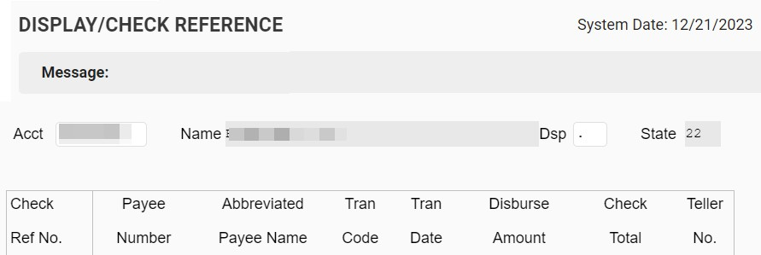

* + 1. The Life of an Escrow Refund Check - Process Flow:

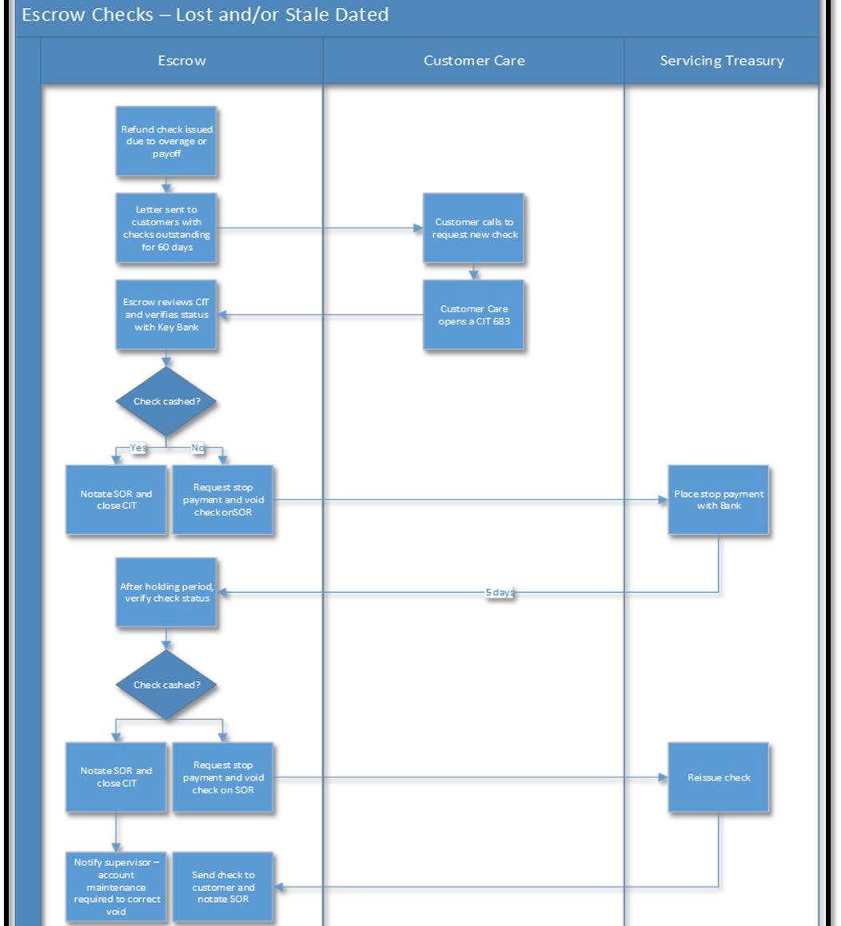

PAYMENTS

# General guidance on using the Escrow Payment fields in Salesforce

* 1. Helpful hint, the text explains when the Escrow Shortage Payment and Escrow Deposit Only fields should be used.
     1. Whenever an amount more than $0 is added to each field, additional RED TEXT will display to let you know how those funds will be used on the account.

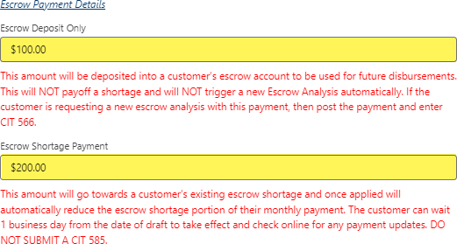

* 1. Escrow Deposit Only –
     1. Generally, use this for anything else outside of escrow shortage where the customer wants deposit funds into escrow.
     2. ***Examples*** *(but not limited to):*
        1. Refunds the customer what to deposit back in.
        2. Extra payments knowing items went up and they want to be proactive prior to a new analysis.
  2. Escrow Shortage Payment –
     1. Use this field when the customer specifically is looking to pay their shortage (assuming they have one) and reduce their payment now.
        1. Reminder that the use of this field eliminates the need to add a CIT 585 (Misapplied Payment Request) to move funds.

# Paying the Escrow Shortage

* 1. When the customer wishes to make a payment to their escrow shortage, take the payment using the “Escrow Shortage Payment” field.
     1. The amount in this field will pass into LoanServ to post directly into Escrow Shortage.
     2. STOP submitting a CIT 585 (Misapplied Payment Request) to move funds.
  2. Once the Payment posts, the funds should be moved to Escrow Shortage and will post as an SRE transaction.
     1. Use the Quick Payment Amount selection “Total Escrow Shortage Only”.

***Note:*** If the customer wants to pay the Escrow Shortage and Full Monthly Payment amount at the same time, it is possible. Simply add the appropriate amounts into the correct fields.

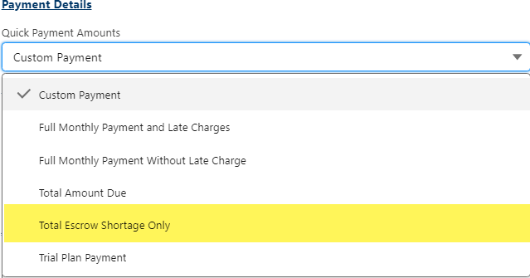

* + 1. Confirm the amount the customer wants to pay into their escrow shortage.
       1. When selecting the quick payment option, the “Escrow Shortage Payment” will be automatically filled in with the total escrow shortage amount.
       2. Adjust the amount according to what the customer wishes to pay.

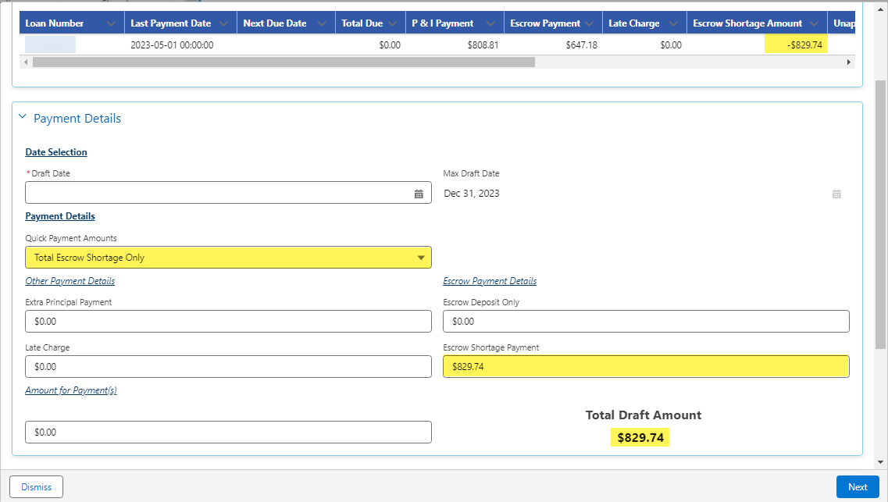

* + 1. Continue selecting the payment options to confirm how they wish to pay and click “Next”.
    2. The amount of the escrow shortage payment will appear on the Authorize page.

***Note:*** The amount that shows up on the authorization text is the total draft amount and may include other amounts depending on what the customer chose.

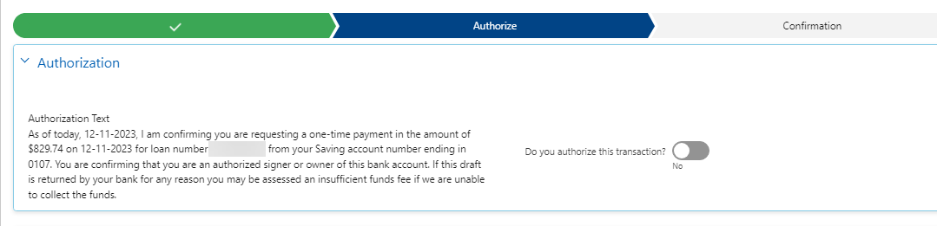

* + 1. Once the customer authorizes the transaction and the email is confirmed, select “Next” to setup the payment.
       1. The payment will be sent to LoanServ and added as a one-time draft.
       2. The amount entered in the “Escrow Shortage Payment” will be added to the appropriate field in the one-time payment screen and reflected in the DIS LOAN screen as being applied to escrow shortage.

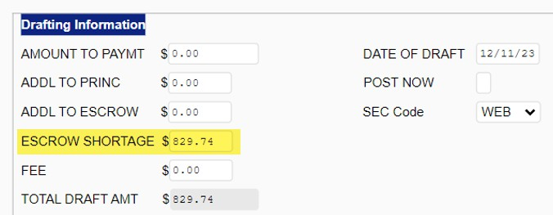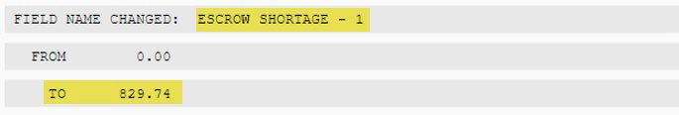

# Overpayments

* 1. If a customer asks if they are permitted to pay extra into their escrow accounts, inform them:
     1. Escrow payments are collected based on the amount billed for taxes/insurance.
     2. Customers are permitted to pay extra into their escrow account to cover taxes and insurance if they think they will have a shortage, but it will not lower their regular monthly mortgage payment.
     3. Customers must specify where the extra funds are to be applied, otherwise the funds will go into Unapplied Funds and may not be handled the way the customer intended.

# Escrow Only Payments – Online (Web Portal)

* 1. Customers can make “Escrow Only” payments using the Make a Payment screen in their online accounts to help plan for future escrow shortages and to minimize shortages ahead of the Escrow Analysis period(s).
     1. A customer can add funds or even an escrow refund back into the escrow.
        1. Payments towards “Escrow Only” can be viewed in the customer’s escrow account in LoanServ.

***Note:*** The “Escrow Only” payment is not an escrow shortage payment. The shortage payment will appear separately, if there is a shortage, and prior to the Escrow Analysis effective date.

* 1. The Specialist should instruct the customer to:
     1. Navigate to the Make a Payment screen.
     2. Under “What type of payment”, click the payment option **Escrow Only**.

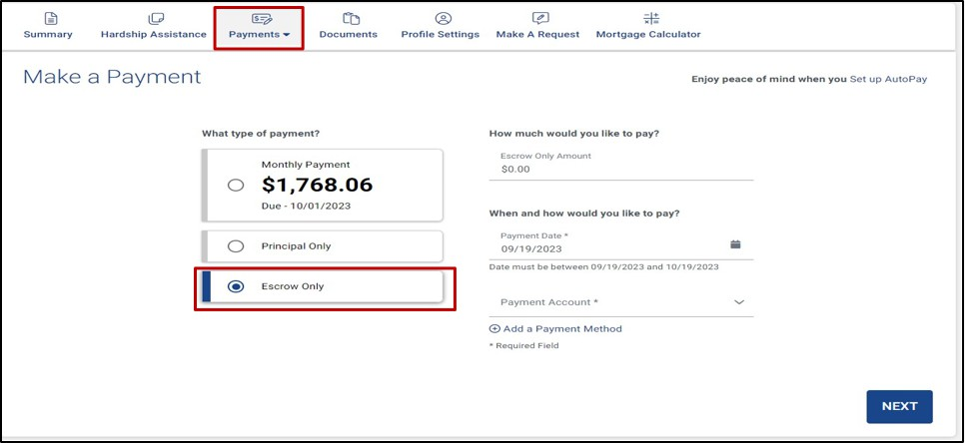

* + 1. Enter the **Escrow Only Amount** they wish to pay, choose the **Date and Payment Account** (saved wallet, if applicable) and then click **Next.**

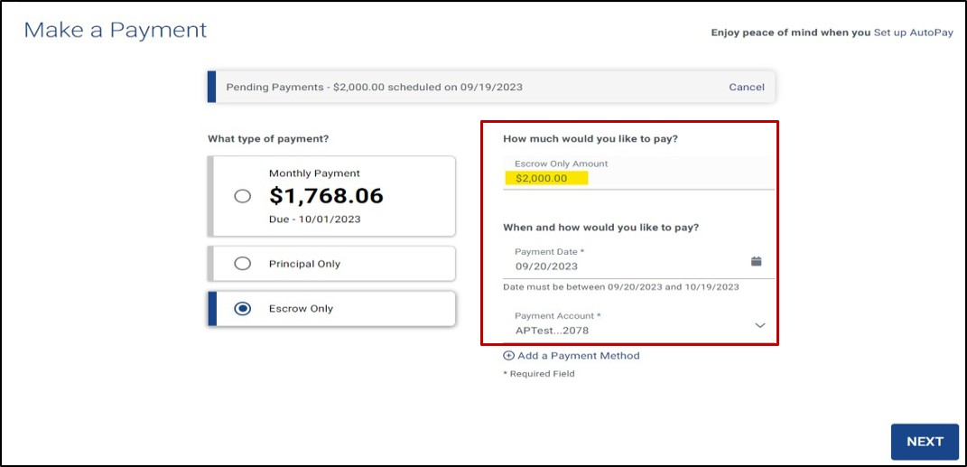

* + 1. Once you review the information to ensure it is correct, click **Submit** and then the Confirmation screen should appear.

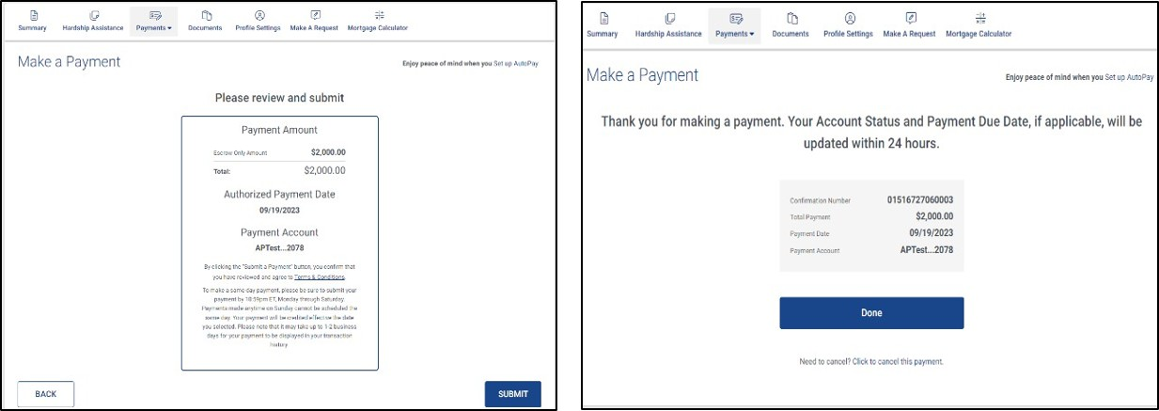

* + 1. Click **Done** to return to the Summary screen.

MOBILE APP CAPABILITIES

# Actionable Items on the Mobile App Home screen

* 1. The first message instructs the customer that the Escrow Analysis is scheduled.
     1. The second message provides additional information on scheduling and when payments will be due.
     2. The third message indicates the Escrow Analysis is ready for the customer to view, along with a link to View Results.

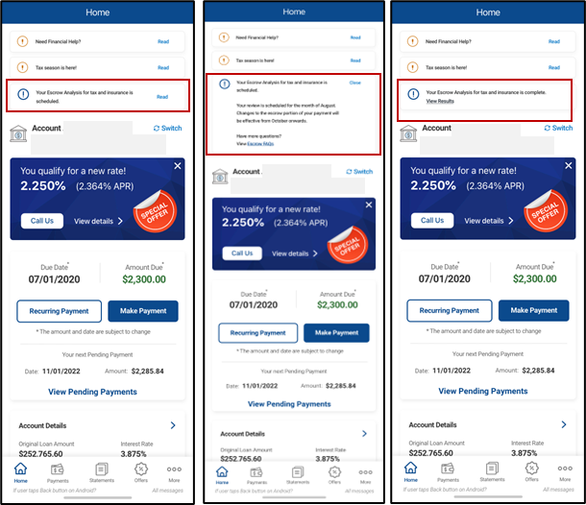

* 1. The customer is then presented with a Summary and an explanation of what to do next.
  2. The customer is provided a breakdown of their insurance and taxes, along with options for payment.

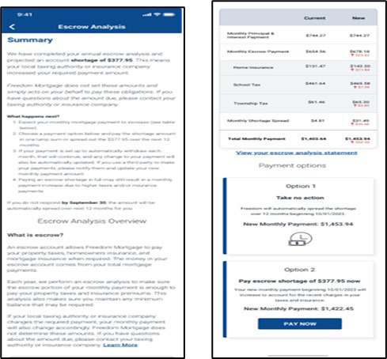

CO-ISSUE LOANS

# What is a “Co-Issue” loan?

* 1. This is a type of loan that Freedom Mortgages receives from other loan originators.
     1. Usually, we receive loans then sell them to investors, Fannie Mae (FNMA) or Freddie Mac (FHLMC), afterwards and keep the right to service them.
     2. However, these loans are already sold to FNMA/FHLMC when we receive them.
        1. Therefore, they’re called “**co-issue**”.
     3. There are no major differences in the way we service these loans.
     4. These loans can be identified by going to the Cust/Orig screen in LoanServ.

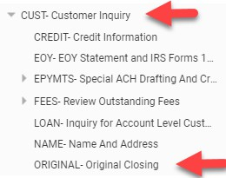

* + - 1. The “Source Code” field will be “CO” for “CO”-Issue.

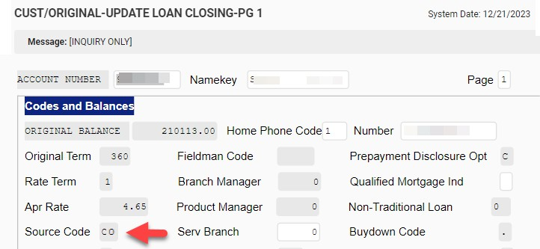

# What happened with these particular loans?

* + 1. Some of the loans were not boarded with the correct escrow payment amount.
    2. In some cases, customers received the monthly billing statement with the incorrect escrow amount and made the wrong payment.
    3. Some payments were short.
       1. Others weren’t but had funds go to principle (rather than escrow).

# What are we doing to correct?

* + 1. We’ve identified each of these loans and corrected the escrow payment amount.
    2. We’re proactively contacting these customers to advise them of the error.
    3. We’re also working to have the customer remit the missing funds if the payment was short and adjust the payment.

# What do I do if I receive a call on one of these?

* + 1. To identify these loans, check the loan account notes in LoanServ.
       1. 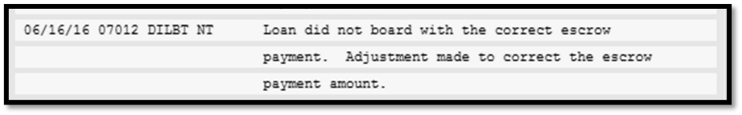A note will be on the account like the one below:
       2. Advise the reason for our call and apologize for the inconvenience.
       3. If the customer made a payment and it was short, advise them of the correct payment.
          1. Offer to take the remainder over the phone free of charge.
       4. If the customer made the payment and it was posted incorrectly to principle instead of escrow, open a CIT 585 (Payment Reallocation Request) to instruct Cash Management to post that portion of the payment to escrow instead.

**APPENDIX**

List of resources that may be useful when performing this process:

* [CIT Reference List](https://fhmc.sharepoint.com/sites/ServicingCallCenterSharepoint/Shared%20Documents/Forms/AllItems.aspx?id=%2Fsites%2FServicingCallCenterSharepoint%2FShared%20Documents%2FCall%20Center%20CITs%2FCIT%20Reference%20List%2Epdf&parent=%2Fsites%2FServicingCallCenterSharepoint%2FShared%20Documents%2FCall%20Center%20CITs&p=true&ga=1)
* Escrow Tax (Call Center) Job Aid
* Freedom Servicing Phone Numbers and Addresses (Call Center)
* [USDA Handbook: HB-1-3555 SFH Guaranteed Loan Program Technical Handbook](https://www.rd.usda.gov/resources/directives/handbooks)
* Mortgage Insurance (PMI_MIP) - Call Center Job Aid
* Ordering a State Trial Report Job Aid
* Unapplied Funds Job Aid